**CM Implementation: Crack Spread**

Group 3

Michael Demian | Yiran Xia | Aravind Ganesan | Rajat Gupta | Sanchi Bhavesh Shah

Introduction:

In general, the prices of goods produced from raw materials and the prices of the raw material should maintain a more constant spread. This paper goes over the implementation of Crack Spread (crude oil to gasoline and heating oil) and trading under a few different parameters for optimization. When the spread of the futures contracts are significantly above or below their moving averages a trading signal is generated, as such deviations are expected to correct over time. Abnormal return series for both basic and refined implementations may be attributed to the effect of rollover of futures contracts. Although the returns could be abnormally high under certain parameters, the volatility of the whole trading strategy allows for a modest Sharpe ratio.

I.  Specification

1. Universe

* This implementation utilizes a universe of futures, specifically WTI (Crude Oil), NY Harbor ULSD (Heating Oil), and RBOB (Gasoline futures)
* For basic implementation, the prices of generic futures contracts from Bloomberg were used, which provide a continuous time series data for the period indicated below
* For Extension, all the contracts for the below mentioned period were used

1. Date Range

* In-sample: Jan 2006 to Dec 2014. Reason for starting at 2006 was that Gasoline (RBOB) futures contract information was only available on Bloomberg from the end of 2005. The period up to Dec 2014 was chosen so as to optimize the strategy for 2 downturns and 2 upturns of the spread. Crack spread for both in-sample and out-sample period provided below
* Out-of-sample: Jan 2015 to Oct 2018

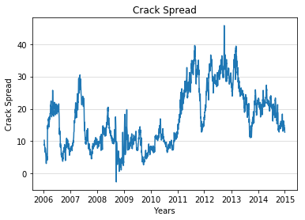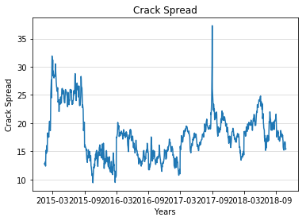

1. Data Sources

* Futures data are collected from Bloomberg. Ticker for the generic future contracts indicated below. **As mentioned above, for Extension, all active contracts were used for the period of back test**
  + Crude Oil Futures – CL1 Comb Commodity
  + Gasoline Futures – XB1 Comb Commodity
  + Heating Oil Futures - HO1 Comb Commodity
  + Risk free rate data from Federal Reserve website
* Construction of generic futures contract was such that the latest contract is considered until it stops trading

1. Signal Generation

* Spread = [42*{(2*Gasoline)+(1*Heating Oil)}-(3*Crude)]/3
  + Gasoline & Heating Oil futures are quoted in per gallon while the Crude Oil futures are quoted in per barrel,. 1 standard barrel is 42 gallons.
  + The spread of 3:2:1 is the most commonly used for crack spread using WTI as most refineries are within this range. Some refineries can produce at 2:1:1 or while others only at 5:3:2. With most WTI crude refineries at 3:2:1 and the average of the 5:3:2 and 2:1:1 converging around 3:2:1, this was chosen as the proper ratio to calculate the spread.
* MA = Moving average of the Spread for a 10 day period
* SD = Standard deviation of the Spread for a 10 day period
* UL = MA + (2*SD)
* LL = MA - (2*SD)
  + There are many combinations of n-day MA periods and SDs that would produce various types of signals. After quite a bit of research into previous models, it was settled on a 10 day period as it allowed for relative mispricings to arise and be acted upon quickly, while still safeguarding against a few day errant pricing. Two SDs was chosen as the volatility in the spreads is already high, requiring what would be a fairly high barrier to entry and allowing for more selectivity in signal generation. The 2 SD mark and 10 day MA period combination was also common in literature yielding generally positive results.
* When current Spread >= UL → Short the Spread
  + Exit the position when the Spread <= MA
* When current Spread <=LL → Long the Spread
  + Exit the position when the Spread >=MA

1. Portfolio Construction

* Short the Spread [current Spread >= UL ]
  + Long 3 crude oil futures contracts
  + Short 2 gasoline futures and 1 heating oil future
* Long the Spread [current Spread <=LL]
  + Short 3 crude oil futures contracts
  + Long 2 gasoline futures and 1 heating oil future
* This enables us to capture the Spread when the Spread moves back to its mean (MA), while staying market neutral
* Every signal will be traded with equal weights

1. Execution

* End-of-day price data is used - Assumptions have been made such that the intraday price movements would not affect the trading performance so that transactions could happen at the previous end-of-day price
* Transaction costs - USD 1.5 per contract and 2 ticks of bid-ask spread. Overall transaction costs assumed at 0.035% of contract value
* Assumed no slippage of our trades

II.  Implementation

1. PnL Graph

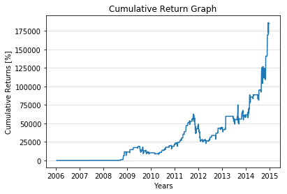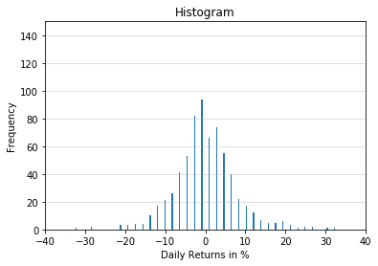

* Cumulative Return = 185,134 %
* Annualized Return = 132 %

**Analysis**

* The strategy has abnormally high positive return during the back-test period. Majority of the abnormality can be attributed to the effect of rollover since future price data used for basic implementation is discontinuous. It is evident from the data indicated below.

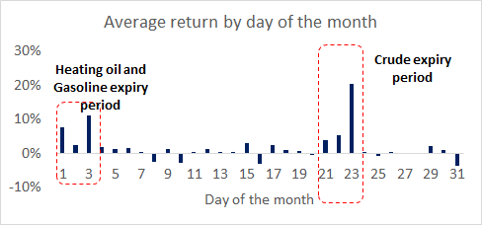

1. Stats

* Distribution of Daily Returns (Histogram available on previous page)
  + Average = 0.6%
  + Standard Deviation = 10.9%
  + Skewness = 26.61
  + Kurtosis = 915.4
* Risk Free Rate = 1.50% (average of the sample period) and Sharpe Ratio = 0.75

**Analysis**

* The daily return distribution exhibits high standard deviation,extremely high kurtosis and positive skew meaning the right tail of the distribution is longer than the left.
* Despite a high annualized return, the Sharpe ratio is low because of high standard deviation
* Maximum drawdown of -63.22% for the strategy occurred from Oct.2011 to May 2012 and the recovery period was 489 days

1. Difficulties

* Negative Spread - During certain period the Spread was negative which impacted our signal. We changed the code to ensure that the appropriate trading signal is generated even when the Spread is negative
* Rollover periods – Abnormalities in return since the futures price data (based on generic future contract) was not smoothed. Addressed in Refinements by taking contract-wise prices
* Handling unstructured data - Handled it by cleaning and structuring the data using Python
* Implementing transaction cost, bid-ask spread etc - Since our implementation was primarily done using the spread and the portfolio was not tracked, to implement transaction cost and bid-ask spread as a percentage of the trading volume was a challenge. It was overcome by calculating it as a percentage of the spread for the historical period and using it in the implementation

III.  Refinements

1. Implemented

* Prices of all futures contracts were used during the indicated date range
  + Prices of over 500 contracts was collected, cleaned and structured in order to run a back-test on it
* Volume of futures contracts reduces one month prior to its expiry starts, this is handled by rolling over during the month prior to its expiry
* Implementation of contract rollover
* Inclusion of transaction cost

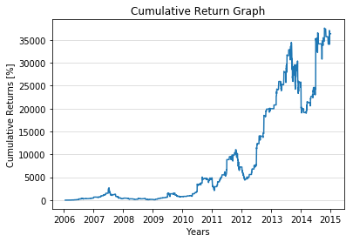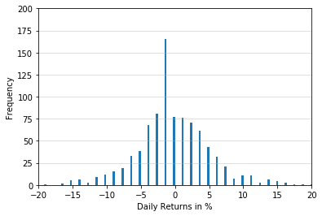

* Cumulative Return = 36,340%
* Total no. of trading days = 2,257
* No. of days with trades = 914
  + No. of days with positive returns = 433
  + No. of days with negative returns = 481
* Annualized Return = 93 %
* Distribution of Daily Returns
  + Average = 0.42%
  + Standard Deviation = 6.22%
  + Skewness = 6.59
  + Kurtosis = 85.93
* Sharpe Ratio = 0.93
* Maximum drawdown of -44.81% for the refined strategy occurred from Sept. 2013 to Mar. 2014 and the recovery period was 118 days

**Analysis**

* The returns for the extension was muted in comparison to the basic implementation since cost/return of rollover and transaction cost was considered. Majority of the return was from the rollover return (Selling a set of relatively high priced contract and rolling over to the relatively low priced contract).

|  |  |  |  |
| --- | --- | --- | --- |
| *Cumulative Return Attribution Analysis%* | | | |
| Strategy | Rollover | Transaction Cost | Total |
| 40% | 197,314% | -87% | 36,340% |

* The strategy exhibits extremely high standard deviation of daily returns of > 6% and the distribution has fat tails (Excess Kurtosis of >6)

1. Proposals

* Refine the trading signal to reduce abnormality in the return distribution
* Incorporating money management - Modelling actual portfolio including margin call among others
* Incorporate high frequency data to analyse the performance of the strategy
* Building a predictive model - Machine learning, NLP etc can be used to build a predict model based on real time news/additional sources of information.

IV.  Conclusion

1. Out of Sample Test(s)

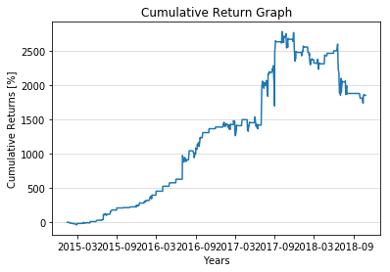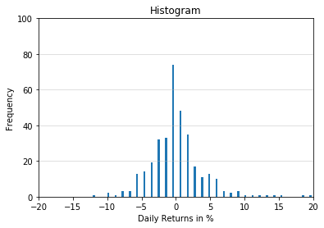

* Cumulative Return = 1,852 %
* No. of years = 3.8
* No. of days with trades = 350
  + No. of days with positive returns = 172
  + No. of days with negative returns = 178
* Distribution of Daily Returns
* Average = 0.38%
* Standard Deviation = 3.96%
* Skewness = 7.73
* Kurtosis = 85.43
* Annualized Return = 119% and Sharpe Ratio = 1.87
* Maximum drawdown of -36.31% for the strategy occurred from Oct.2017 to Oct. 2018 and not yet recovered

**Analysis**

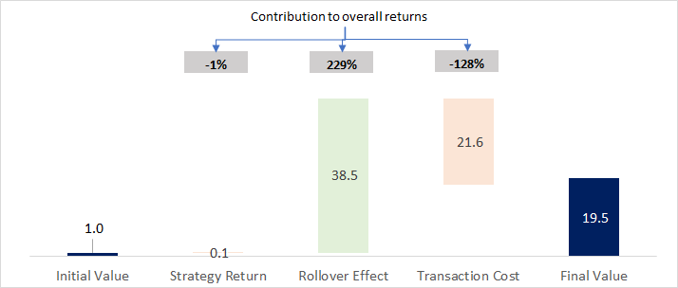

The out-of-sample back-test yielded abnormally high positive returns. The daily returns exhibited high standard deviation and fat tails. The results were less abnormal in comparison during this period. Majority of the returns were from the rollover which was implemented as a part of the extension.

1. Trading Recommendation

Despite the high returns during in-sample and out-sample testing, the high volatility and uncertainty makes this strategy a very risky play. It is not recommended to trade this strategy as it could easily cause a very quick, large loss if undertaken at the wrong time.

V.  Appendix